BD LSRFortessaTM SORP

Description
The BD LSRFortessaTM SORP is a benchtop digital flow cytometer. Equipped with 5 spatially separated lasers, 18 fluorescent detectors and 2 light scatter detectors for fast multicolour analysis with accurate data acquisition rate at up to 40,000 events per second (with beads). The BD LSRFortessaTM has a BDTM High Throughput Sampler (HTS) for increased lab productivity by acquiring samples from a 96- or 384-well plates.

Applications
Multicolour flow cytometry analysis.

Excitation Optics
Laser power
355 nm: 20 mW
405 nm: 50 mW
488 nm: 100 mW
561 nm: 50 mW
640 nm: 40 mW

Emission Optics
Forward Scatter Detector: photodiode with 488/10 bandpass filter for the 488-nm laser.
Side Scatter Detector: photomultipler with a 488/10 bandpass filter for the 488-nm laser.
Fluorescence Detectors and Filters:
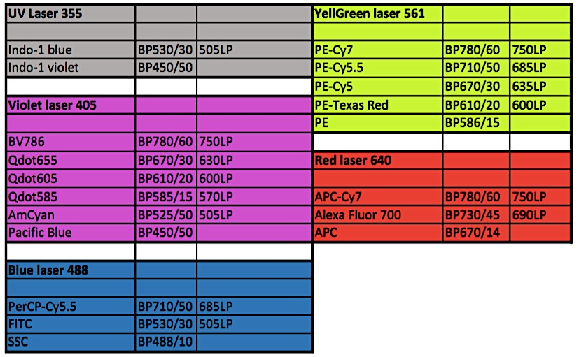

Available filters
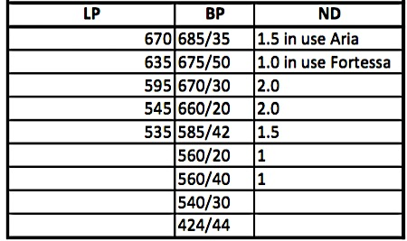

Fluidics
Sample flow rates
Front key panel provides three modes: RUN, STANDBY, and PRIME

Continuously adjustable flow rates, plus three preset flow rates:
LO: 12 µL/min
MED: 35 µL/min
HI: 60 µL/min

Performance
Fluorescence Sensitivity
- FITC : 80 molecules of equivalent soluble fluorochrome (MESF-FITC)
- PE: 30 molecules of equivalent soluble fluorochrome (MESF-PE)
- PE-Cy™5: 10 molecules of equivalent soluble fluorochrome (MESF-PE-Cy5)
- APC: 70 molecules of equivalent soluble fluorochrome (MESF-APC)

FITC and PE measurements performed using SPHERO™ Rainbow Calibration Particles (RCP-30-5A) PE-Cy5 and APC measurements performed using SPHERO Ultra Rainbow Calibration Particles (URCP-38-2K)

Fluorescence Resolution
Coefficient of variation (CV) PI: Area, <3.0%, full G0/G1 peak for PI-stained chicken erythrocyte nuclei (CEN)

Fluorescence Linearity
Doublet/singlet ratio CEN stained with PI: 1.95–2.05 (488-nm laser)

Forward and Side Scatter Sensitivity
Sensitivity enables separation of fixed platelets from noise, identification of bacteria, and detection of 0.5-µm beads.

Forward and Side Scatter Resolution
Scatter performance is optimized for resolving lymphocytes, monocytes, and granulocytes.

Signal Processing
Converter
10-MHz analog-to-digital converter.

Workstation Resolution 262,144 channels

Pulse Processing: height, area, and width measurements available for any parameter. Ratio measurements are also available.

Time can be correlated to any parameter for kinetic experiments or other applications.

BD™ High Throughput Sampler (HTS)
is available to increase your lab productivity by acquiring samples from a 96- or 384-well microtiter plate.
HTS throughput
Acquisition: less than 15 minutes per microtiter plate in high throughput mode using a 2-second acquisition,
less than 44 minutes in standard mode using a 10-second acquisition
Carryover: <0.5% HT mode
<0.75% STD mode

Link to the manufacturer BD Biosciences

Recommended tool for multicolour experiment design: SpectrumViewer

