BD FACSAriaTM Fusion

Description
Fluorescence activated cell sorter (FACS) with a quartz cuvette flow cell that is in fixed alignment with the laser, and is gel coupled to the collection optics. BD FACSAriaTM Fusion is equipped with 5 spatially separated lasers, 18 fluorescent detectors and 2 light scatter detectors for fast multicolour analysis and cell sorting with accurate event data acquisition at up to 70,000 events per second. BD FACSAriaTM Fusion is placed in the biosafety cabinet (BSC) Class II Type A2, designed in collaboration with The Baker Company, a leader in biosafety solutions.

Applications
Flow cytometry analysis and fluorescence activated cell sorting.

Excitation Optics
Fixed optical alignment of all Class IIIb lasers with the cuvette flow cell. All lasers are solid state and elliptical:
Beam height: 9 ±3 µm
Beam width: 65 ±7 µm

Power Out of the Laser Head
355 nm: >20 mW
405 nm: >85 mW
488 nm: >50 mW
561 nm: >50 mW
640 nm: >100 mW

Emission Optics
Forward Scatter Detector: photodiode with 488/10 bandpass filter for the 488-nm laser.
Side Scatter Detector: photomultipler with a 488/10 bandpass filter for the 488-nm laser.
Fluorescence Detectors and Filters:
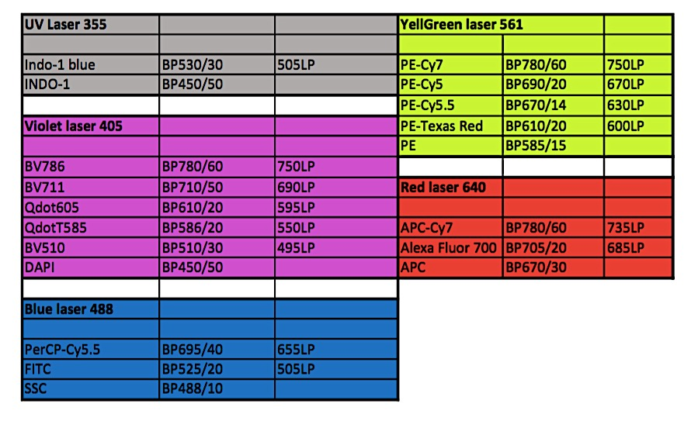
Fluidics
Sheath pressure is adjustable from 5 to 75 psi.
Sample Flow Rates adjustable dynamic range.
Nozzles are removable and can be sonicated; available in 3 sizes: 70, 85 and 100-µm
Temperature control of sample input: 4ºC, 20ºC, 37ºC, and 42ºC (adjusted in the software); sample output: from +5°C to +42°C
Collection devices: 15ml- and 5ml-tubes, eppendorfs, 6, 24, 96, and 384-well plates. Index sorting can be enabled when sorting single cells. This capability indexes the cell surface phenotype to the well containing that cell.
Performance
Fluorescence Sensitivity
Measurements performed at 70 psi and 90 kHz using SPHERO™ Rainbow Calibration Particles (RCP-30-5A).* *MESF, can vary lot-to-lot.
- FITC <87 molecules of equivalent soluble fluorochrome (MESF-FITC)
- PE <29 molecules of equivalent soluble fluorochrome (MESF-PE)

Fluorescence Resolution
Coefficient of variation (CV)
- PI: Area, <3.0%, full G0/G1 peak for PI-stained chicken erythrocyte nuclei (CEN)
- Hoechst: Area, <3.5%, full G0/G1 peak for Hoechst-stained chicken erythrocyte nuclei (CEN)

Fluorescence Linearity
Doublet/singlet ratio CEN stained with PI: 1.95–2.05 (488-nm laser) or Hoechst: 1.95–2.05 (405-nm laser)

Forward and Side Scatter Sensitivity
Sensitivity enables separation of fixed platelets from noise, identification of bacteria, and detection of 0.5-µm beads.

Forward and Side Scatter Resolution
Scatter performance is optimized for resolving lymphocytes, monocytes, and granulocytes.

Sort Performance
Drop Drive Frequency
Range: 1–100,000 Hz

Purity and Yield
At 70 psi and 87 kHz with an average threshold rate of 25,000 events per second, a four-way sort achieved a purity of >98% and a yield >80% of Poisson’s expected yield. Higher threshold rates up to 70,000 events per second can be achieved without affecting purity. However, yield will decrease based on Poisson’s statistics.

Functionality
Dendritic cells (myeloid and plasmacytoid, mDs and pDCs, respectively) were isolated from the peripheral blood mononuclear cells of three donors and sorted on the BD FACSAria III system (one sort per donor) which uses the same cuvettebased flow cell design as the BD FACSAria Fusion. Post-sort cell viability was assessed using a live/dead exclusion marker, and functionality was assessed by intracellular cytokine staining after 6 or 18 hours of stimulation with the TLR 7 & 8 agonist R848. Post-sort viability at 6–18 hours was >90% for all three donors. Both pDCs and mDCs for all three donors produced IFN-a, TNF-a, and IL-12 stimulation, demonstrating post-sort functionality.

Sort Collection Devices
Two-way sorting: 12 x 75-mm and 15-mL tubes
Four-way sorting: 1.5-mL microtubes and 12 x 75-mm tubes
Single cell sort into multiwall plates: 6-; 24-; 96-; 384-well plates

FACS™ Accudrop
Red diode laser provided for fully automated drop-delay determination
Automated drop breakoff monitoring
Automated clog detection and sort tube protection system using Sweet Spot technology

Signal Processing
Converter
10-MHz analog-to-digital converter. Pulse sampling is precisely matched to the particle flow rate in the cuvette. Particles travel slower compared to conventional stream-in-air sorters. This increases the light collected, resulting in better sensitivity. High-speed sorting is achieved by accelerating the stream through the nozzle, achieving drop rates comparable to stream-in-air sorters. The flow cell design and electronics are matched to maximize signal while maintaining maximum sort speed, purity, and yield.

Workstation Resolution 262,144 channels

Pulse Processing: height, area, and width measurements available for any parameter. Ratio measurements are also available.

Time can be correlated to any parameter for kinetic experiments or other applications.

Link to the manufacturer BD Biosciences

Recommended tool for multicolour experiment design: SpectrumViewer

